User Manual of AF120R
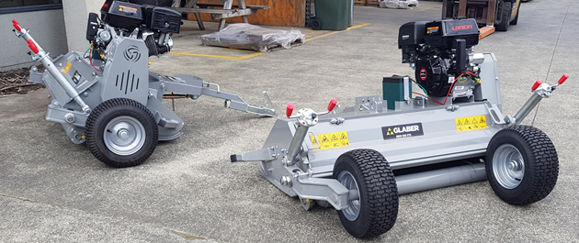Flail Mower for AF120R

Description: Flail mower for mounting on ATV. 420 cc engine with electrical start. The wheels can be fitted on the sides or on the rear of the flail mower. Equipped with double spindles for easy and fast adjustment of the cutting height. With adjustable drawbar.
Application: Designed to cut grass and other forms of vegetation.
Intended use: Use the flail mower only as described in this manual. All other use is deemed incorrect.
Technical specifications

Width: | With wheels fitted on the side: 193.5 cm
 | With wheels fitted on the rear: 167.3 cm
Engine: | Model: Loncin G420F  420 cc 4-stroke with electrical starter
Capacity: | 5,750 m2/hour (at 5 km/h)
Fuel tank, capacity: | 6.5 l
Fuel: | Petrol 92 octane or higher
Engine oil amount: | 1.1 l
Engine oil type: | 10W-40 or alternatively, 15W-40
Rotor drive: | Wrap spring clutch with triple belt drive
Operating speed: | Max: 10 km/h
Wheel size: | 16 x 6.50-8
Flails: | 28 hammer flail
Working width: | 115.5 cm
Cutting height: | 0.9–20 cm
Dimensions (L x W x H): | With wheels fitted on the rear: 2007 x 1673 x 881mm  With wheels fitted on the side: 1878 x 1935 x 881mm
Weight: | 260 kg
Noise level: | 83 dB

Contents
Technical specifications………………………………………………………1
Safety instructions………………………………………………………….3
Safety labels……………………………………………………………………4
Overview of equipment…………………………………………………….5
User instructions……………………………………………………………….6
Inspection of equipment……………………………………………….6
Adjusting the drawbar……………………………………………………6
Setting the cutting height………………………………………………7
Starting the engine…………………………………………………………8
Operation……………………………………………………………………….8
Stopping the machine…………………………………………………….9
Transport………………………………………………………………………..9
Adjustment of roller and skid shoes……………………………….9
Maintenance………………………………………………………………….10
Maintenance schedule……………………………………………….10
Remove deposited/accumulated material………………….11
Visual inspection………………………………………………………..11
Tyre pressure…………………………………………………………………11
Check and lubrication of main axle and roller………….12
Wheel bearings check…………………………………………………….12
Change the wheels’ positioning………………………………….12
General inspection……………………………………………………..12
Maintenance of flails………………………………………………….12
Exploded-view drawing………………………………………………….13

Safety instructions
    - The flail mower must not be used if any of the guards are not fitted correctly.
    - Never change the engine’s factory settings.
    - Never touch moving or rotating parts.
    - Never stop the engine immediately after heavy use but allow the machine to operate in idle for approx. one minute.
    - Do not use the flail mower without appropriate ear protectors and safety goggles.
    - Never permit passengers on the flail mower.
    - Never leave the equipment unattended when it is operating.
    - Do not allow the engine to operate in a closed area as the exhaust gases contain carbon monoxide, which can cause death if inhaled.
    - Do not use the flail mower on very steep inclines.
    - The flail mower must not be used if any of the safety devices are incorrectly fitted or are not fully functioning.
    - Do not use the equipment without having read and understood the entire user manual.
    - Do not wear loose-fitting clothing, as this can get caught in the machine.
    - Never attempt to remove trapped material while the engine is operating. Ensure that the engine and main axle have stopped moving before carrying out any kind of servicing of the flail mower.
    - Never use the flail mower in the dark. Only use the flail mower when there is sufficient
artificial or natural light.
    - Never use the flail mower if there are excessive vibrations – stop the machine immediately and refer to the machine schedule.
    - Never stand on the flail mower.
    - Keep bystanders at a safe distance.
    - Ensure that the flail mower is maintained and serviced before use.
    - Remove any potentially harmful objects from the work area.
    - Reduce speed on inclines and on hard terrain.
    - Be aware that components can be hot after use.
    - Follow the ATV manufacturer’s recommendations for towing at all times.
    - Exercise extreme caution when filling with fuel, especially if the engine is till warm.
    - Ensure that the safety labels are in a good, legible condition – replace if damaged.
    - Keep hands and feet away from the rotary blades.
    - Ensure that the flail mower is in the transport position before transporting it.

Safety labels

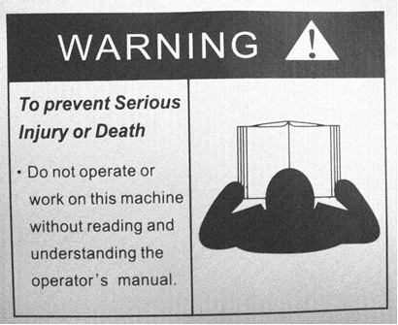

KEEP WHEEL NUTS TIGHT CHECK DAILY REFER TO THE OPERATOR’S MANUAL
FOR CORRECT TYRE INFLATION PRESSURE
OBSERVE TOWING VEHICLE MAX TOWING LIMITS OR TRAILER MAX WEIGHTS.

ATTENTION
Your responsibilities before operating this machine are:
．Read, understand and follow the safety procedures manual
．Train operators before using and review safety procedures regularly
．Ensure that all guards are in place
．Keep hands, feet, hair and clothing away from all moving parts
．Avoid wearing loose clothing whenever possible
．Maintain as per schedule in the safety procedures. Especially blades and securing hardware, due to the hazard they present should any part break loose during operation
．During maintenance, use suitable support stands
．DO NOT allow any persons to ride on the equipment
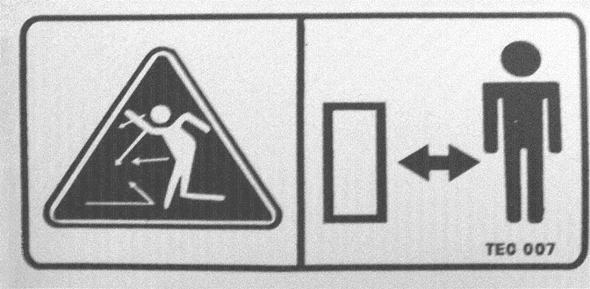

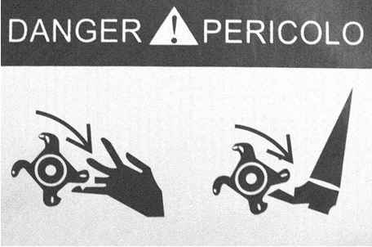

The above safety labels must be placed on the flail mower. If some of the above labels are missing or are damaged, contact the supplier to order more.


Overview of equipment 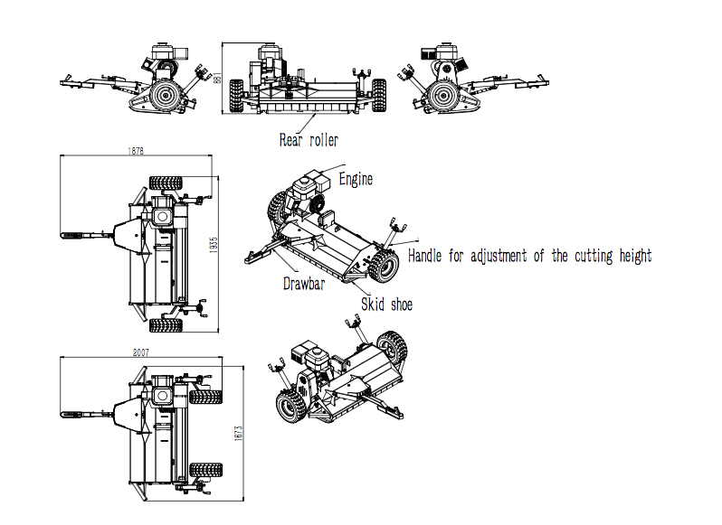

User instructions

Under normal operating conditions, the machine has a noise level of 83 dB –
so ear protectors must be worn!

Inspection of equipment
Carry out the following inspection before using the machine:

- Make sure that all bolts, nuts and joints are tightened correctly.
- Check that the engine is filled with oil and the petrol tank is filled with petrol.
- Check the tyre pressure.

Adjusting the drawbar

The coupling height on the ATV can vary. Therefore, a spindle is positioned under the drawbar. It can be extended or shortened so that the cutting deck is level with the ground (this ensures better cutting efficiency).

Adjustment procedure

- Loosen the locking nut (A).
- Extend the spindle to lower the front of the cutting deck and shorten the spindle to raise front of the cutting deck.
- When the cutting deck is even, re-tighten the locking nut (A).
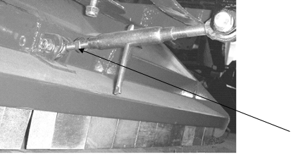

A

Quick removal of the drawbar

Pull back the locking bolt and push the drawbar to the desired position and insert the locking bolt in the desired hole, as shown.

Clamp bolt
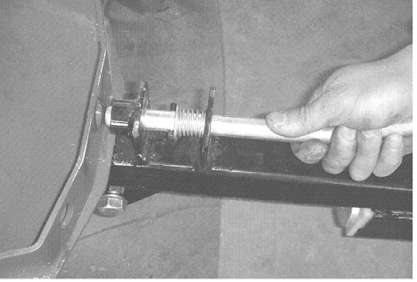



Setting holes

Setting the cutting height

Adjust the cutting height by using the handle to raise or lower the cutting deck to the desired height.

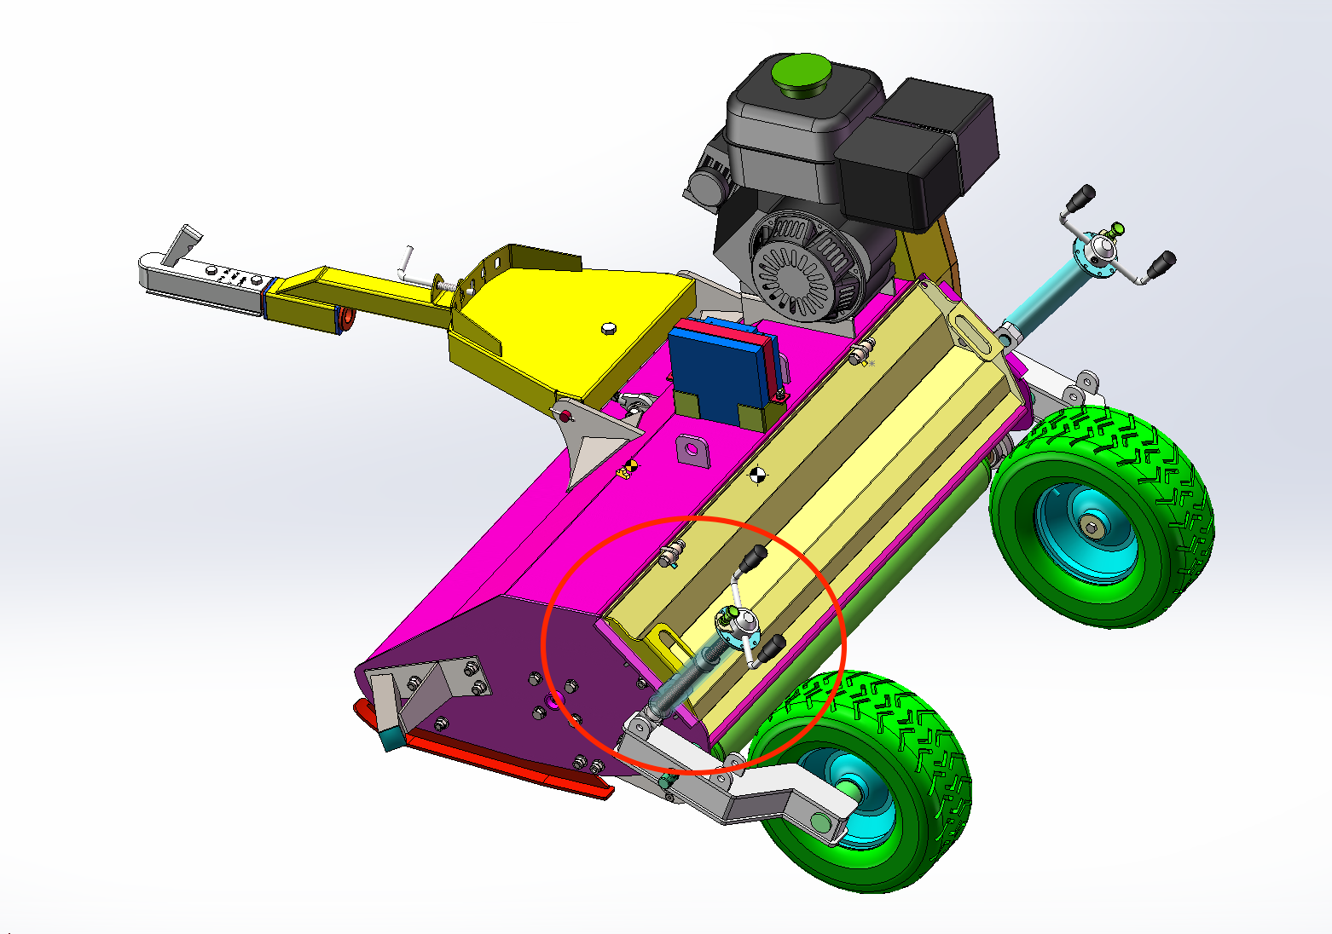

Starting the engine

Recoil starter
- Ensure that there is space between the flails and the ground/vegetation.
- Choose an area that is free of any loose material that could be picked up.
- Set the choker and set an appropriate idling speed by using the throttle.
- Position a foot on the top of the cutting deck to achieve a fixed and good working posture. Pull the start handle/cord firmly and allow the cord to recoil slowly (one or two firm pulls should start the engine).
- Allow the engine to run in idle for a few seconds to warm up the engine. Move the throttle to the factory-set operating position to get the engine to operate at normal/operating rpm, which is max. 3,600 rpm.

Do not make changes to the engine’s factory settings – otherwise the cutting efficiency will be adversely affected; fuel consumption will increase and
vibrations will occur that can lead to a potential hazard to people and
material, and the warranty will also be void.

Electrical start

The flail mower is equipped with an electrical start: Connect the flail mower’s electrical cable to the ATV connector and switch on the ATV using the ignition key and the flail mower will also start. Follow the same precautions as with the recoil start.

Operation

The amount of grass that is to be cut determines the speed of operation. In most cases, the best results are achieved at lower speeds.

Normal operating speed (1 km/h – heavy operating conditions – 10 km/t – light operating conditions).
Always start with the lowest possible speed and check that the flail mower is operating efficiently at max. rpm without the engine becoming overloaded. (If the working conditions are too heavy, raise the flail mower’s cutting height and cut the grass. Be prepared afterwards to cut the grass again at a lower cutting height. Ensure that you wait long enough between each mowing to allow the grass to dry.)
Increase the speed until the engine begins to lose rpm. This indicates that the engine is becoming loaded because the working conditions are becoming too heavy. Reduce the speed and allow the engine to return to full rpm and repeat the procedure but do not reach the speed that previously overloaded the engine.

It is important to listen to the engine to ensure that the engine and the flail mower operate efficiently. Lower the speed and stop if the engine becomes overloaded.

Failure to do this may result in coupling failure and cause serious damage to the coupling and drive belt.

When conditions change from normal operation to heavy operation, you may notice the engine overloads and loses rpm. REDUCE SPEED IMMEDIATELY and

allow the engine to return to the rpm for normal working speed. Follow the guidelines for normal speed 1–10 km/h. The speed will be very slow in heavy working conditions.

Failure to do this may result in coupling failure and cause serious damage to the coupling and drive belts.

Stopping the machine

When the engine has operated in heavy conditions for a period of time, allow the engine to operate at half-power for at least one minute to allow the drive belts to cool down.

- Exercise extreme caution because of hot parts, e.g. the exhaust, belts, etc., and also when the engine has been switched off.
- Ensure that the drawbar is aligned straight out behind the ATV.
- Once the flail mower has cooled down (it takes at least an hour), remove all of the grass and dirt from the engine’s cooling fins, the area around the drive belts and the main axle.

Transport

When moving the flail mower from one work area to another, it is recommended that the cutting deck is set to the highest position. (Transport position – see the section “Setting the cutting height”).
Before adjusting the height, ensure that the engine is switched off and the flails have stopped moving.
Remove any deposits from the cutting deck before leaving the work area.
Always ensure that the flail mower’s engine has been switched off when transporting the machine to the next work area.

Adjustment of roller and skid shoes

The roller’s most important function is to protect against damage to the main axle – if a wheel enters a hole or if the surface is uneven, causing height differences between the two wheels, the roller supports the flail mower’s weight, which prevents the flails from ‘flailing’ the ground. Together with the skid shoes, the roller provides excellent protection to the main axle.
The roller also provides the benefit where it is possible to cut edges since one wheel can move over the edge.
The roller and the skid shoes’ positions are factory-set and will suit many situations, but they should always be adjusted to suit the conditions. If the flail mower e.g., is used in heavy working conditions or on tough vegetation, the roller and the skid shoes should be lowered to increase the free height between flails and underground.

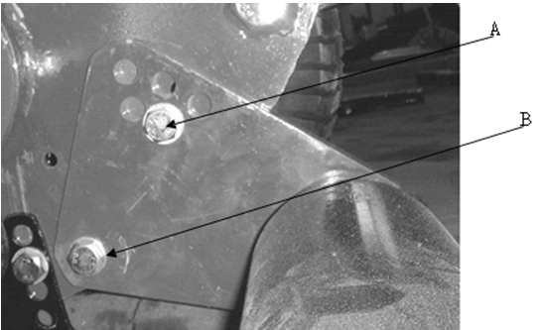

Procedure to adjust the roller

Loosen the pivot bolt “A”.
Loosen and remove bolt “B”
(Repeat on the other side).
Select a new hole and insert bolt “B”.
Tighten both bolts in both sides.

Procedure to adjust the skid shoes

Remove the bolts in front and rear of the skid shoes. Choose a new setting, re-insert the bolts and tighten them. Repeat on the opposite skid shoes. Always ensure that both skid shoes are set uniformly.

Maintenance

Maintenance schedule

Maintenance task: | Every hour | Daily | Weekly | Once per season
Remove accumulated material from the  cutting deck | • | • | • | •
Remove accumulated material from the main  axle | • | • | • | •
Visual inspection, check for loose parts |  | • | • | •
Lubricate height-adjustment handle |  | • | • | •
Lubricate the rear roller |  | • | • | •
Lubricate the main axle’s bearings |  | • | • | •
Check the tyre pressure |  |  | • | •
Check pulley bolts are tight |  |  | • | •
Check the drive belts |  |  | • | •
Check the main axle’s bearings |  |  | • | •
Check the wheel bearings |  |  | • | •
Lubricate the 50 m coupling |  |  | • | •
Check the spindle (drawbar) for wear |  |  | • | •
Check all of the joints are correctly tightened  and are intact |  |  | • | •
Check the safety labels |  |  |  | •
Check the flails’ state/check for wear |  | • |  | •
Check for metal fatigue |  | • |  | •
Check coupling for wear/function |  |  |  | •

Remove deposited/accumulated material

Ensure that all deposited material is removed from the cutting deck and the engine area. Accumulated material can cause the machine to overheat and result in fire.
Remove the spark plug lead.
Remove all forms of material wrapped around the main axle (A) or any material stuck below the cutting deck.
Lift the deck to max. height to gain easier access to the area.

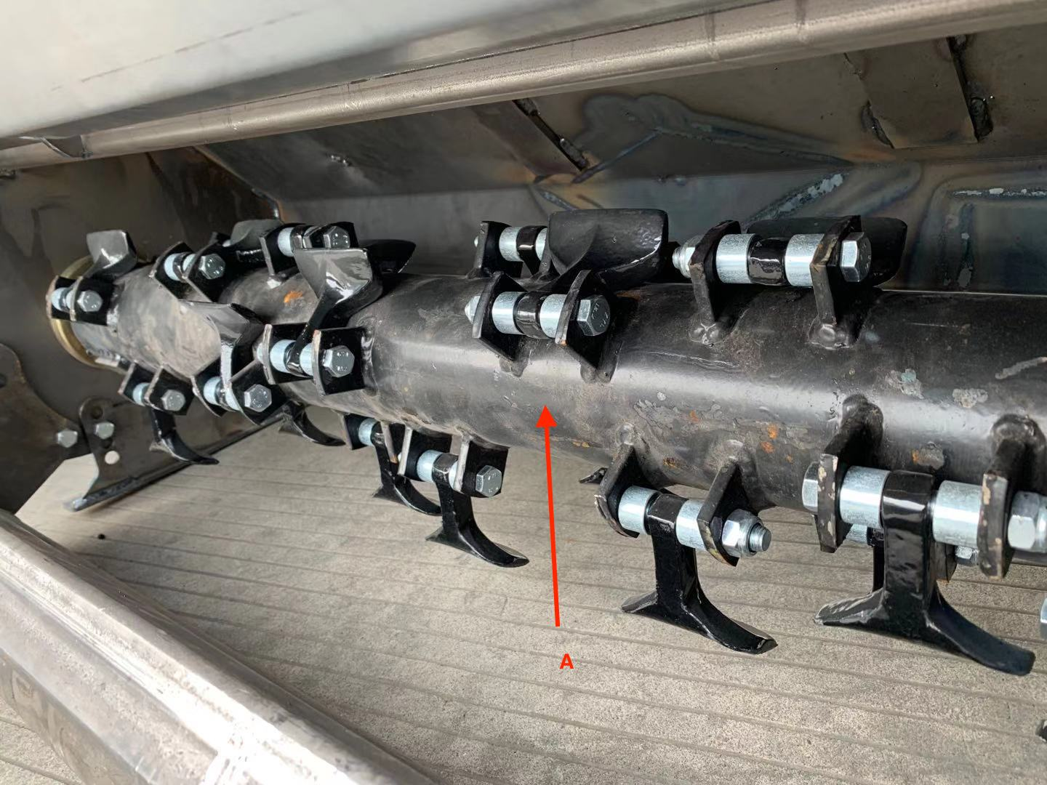

Visual inspection

Inspect the flail mower all over. Check for missing, loose or damaged components. All defects or deficiencies must be remedied.

Tyre pressure
Do not exceed the recommended tyre pressure.

16 x 6.50 - 8
28 psi (max.)

Check and lubrication of main axle and roller
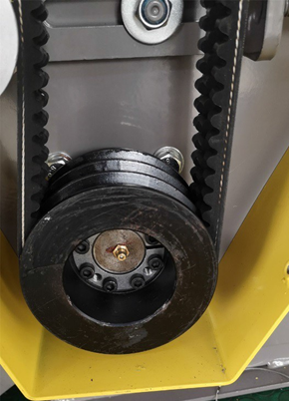
Turn the main axle by hand to ascertain if there are any irregularities with the bearings. Also try to pull the axle from side to side to check that it can be moved. If a defect is discovered, remove the guards and check the bearings.

The machine is equipped with grease nipples that can be accessed by removing the belt guard and / or removing the small rubber cover.

Note that if the wheels are mounted on the side of the machine, it may be necessary to remove them.

Wheel bearings check

Raise one side of the machine, so that the wheel is lifted from the ground. Rotate the wheel by hand and check whether the wheel turns freely. To check the bearings, try to move the wheel from left to right and feel if there is any play in the bearings (A). First check the wheel bolts are correctly tightened. If there is play, remove the wheel and check the bearings. Replace defective bearings.

Change the wheels’ positioning
Remove the bolts and turn the bolts, as shown:

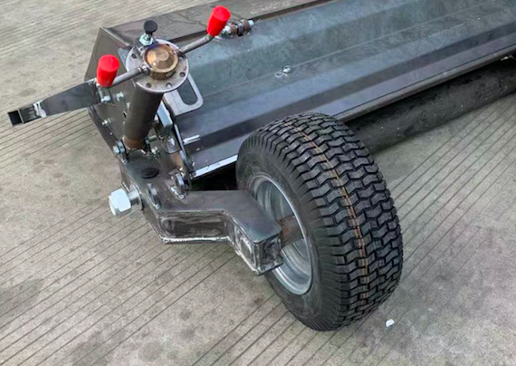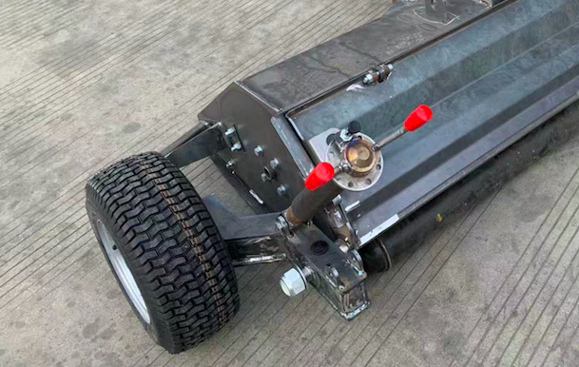

General inspection

Inspect the flail mower to ensure that all of the joints are tightened and that all safety guards are intact and correctly fitted. Check all of the safety labels. Replace any defective guards and damaged labels.

Maintenance of flails

The flails are designed to have a long lifetime. Should they break or fall off, it is very important to replace then immediately. If they are not replaced, it will cause serious balance problems.

When replacing a flail, the opposite flail should be checked for wear. If it is worn or very worn it should be replaced to maintain the weight balance. Blunt flails reduce the flail mower’s cutting efficiency and increases fuel consumption.

Procedure to replace or reverse the flail:

  - Ensure that the flail mower’s engine is stopped and that the main axle has completely stopped. Close the fuel cock and allow the machine to cool for five minutes. Remove the spark plug so that the machine cannot be unintentionally started.
  - Raise the cutting height to maximum.
  - Carefully lift the drawbar so that the rear roller on the flail mower supports the weight. NB: Do not attempt to do this if the wheels are fitted on the rear of the flail mower!
  - Loosen and remove the bolt.
  - Replace or reverse the flail (take the direction of rotation into consideration).
  - Insert the bolt and tighten it well, but ensure that it can still rotate.

NB: Never use damaged or repaired bolts or fittings when replacing hoses. If the fitting has become damaged or worn, it must be replaced with a new fitting.

Any repairs and service other than the minor adjustments described here, should be carried out by a qualified professional.

Exploded-view drawing

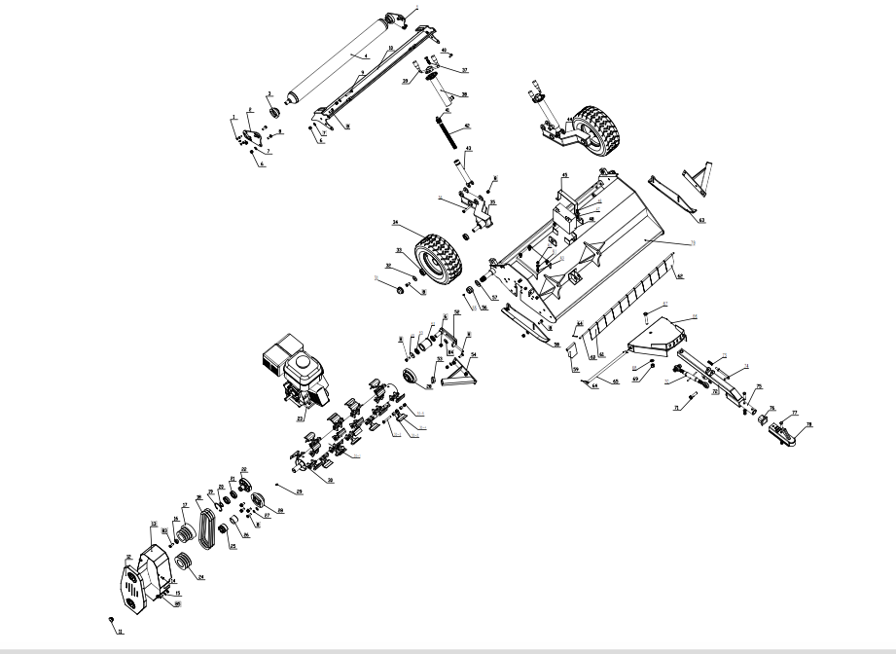

New version AF120R
No. | Code | Description | Qty
1 | GB/T 2673-86 | Bolt M8*25 | 8
2 | ATV120.10 | Connection and adjustment plate for rear roller (Left) | 1
3 | UC205 | Bearing UC205 | 2
4 | ATV120.19 | Rear roller weldment | 1
5 | ATV120.11 | Connection and adjustment plate for rear roller (Right) | 1
6 | GB/T 889.1 | Nut M12 | 34
7 | GB/T 97.1-85 | Washer 12 | 33
8 | GB/T 5783-86 | Bolt M12*30 | 27
9 | GB/T 5783-86 | Bolt M12*60 | 2
10 | ATV120PL.12 | Rear open door weldment | 1
11 |  | Rubber plug | 1
12 | ATV120.13-04 | Top belt cover | 1
13 | ATV120.13 | Belt cover weldment | 1
14 | GB/T 5783-86 | Bolt M8*16 | 4
15 | GB/T 97.1-85 | Washer 8 | 4
16 | ATV120.18.04 | Cover for top pulley | 1
17 | ATV120.18.05 | Top belt Pulley | 1
18 | GB/T 1171-74 | Belt SPB1016 | 3
19 | GB/T893.1 | Inner circlip 60 | 1
20 | GB/T894.2 | Outside circlip 35 | 1
21 | GB/T 276-94 | Bearing 6007 | 2
22 |  | Clutch | 1
23 | 420CC | 15HP Engine | 1
24 | ATV120.18.06 | Down pulley | 1
25 | JB/T7934Z3 | powr lock 04 type 35*60 | 1
26 | ATV120.18.03 | bushing | 1
27 | GB93-87 | spring washer 12 | 10
28 | UC207 | Bearing UC207 | 2
29 | GB/T7940.1 | Grease nipple M8*1 | 4
30 | ATV120.07 | Rotor assembling | 1
30-1 | ATV120.07.01 | Rotor weldment | 1
30-2 | GB/T 5782 | Bolt M12*80 | 28
30-3 | EF100.00.101 | Bushing | 56
30-4 | EF100.00.102 | Hammer | 28
30-5 | GB/T 889.1 | Nut M12 | 28
31 |  | Wheel cap | 2
32 | ATV120.22.02 | Plate | 2
33 | GB/T 276-94 | Bearing 6205 | 4
34 | 5110961 | Wheel | 2
35 | ATV120.31.1 | Wheel bracket ( Left) | 1
36 | GB/T 5782 | Bolt M12*80 | 2
37 | MT302Z-M12-8 | Locking pin | 2
38 | ATV120.30.1 | Outter tube weldment | 2
39 | ATV120.30.4 | Spindle weldment | 2
40 | GB/T70.1 | Bolt M8*25 | 2
41 | GB/T 301-1995 | Bearing 51104 | 4
42 | ATV120.30.2 | Lead screw | 2
43 | ATV120.30.3 | Inner tube weldment | 2
44 | ATV120.32.1 | Wheel bracket ( Left) | 1
45 | ATV120.24 | Plate for battery | 1
46 | GB/T 889.1 | Locking Nut M8 | 2
47 | GB/T5783 | Bolt M8*20 | 2
48 |  | Battery 12V | 1
49 | ATV120.15.03 | Washer | 1
50 | GB/T 276-94 | Bearing 16005 | 2
51 | ATV120.15.02 | Tension roller | 1
52 | ATV120.15.1 | Brackets for tension roller | 1
53 |  | Rubber plug | 2
54 | ATV120.16 | Protection weldment | 2
55 | GB/T7940.1 | Grease nipple M6*1 | 2
56 | GB/T 889.1 | Nut M30 | 2
57 | GB/T 97.1-85 | Washer 30 | 2
58 | ATV120.08 | Skid (Left) | 1
59 | EF100.00.122A | Fender | 1
60 | ATV120.18.07 | Bar for fender | 1
61 | EF100.00.122 | Fender | 10
62 | EF100.00.122B | Fender | 1
63 | ATV120.09 | Skid (Right) | 1
64 | GB/T91-2000 | Cotter pin | 4
65 | ATV120.18.02 | Bar | 1
66 | ATV120.01.01 | Linkage weldment | 1
67 | GB/T 5782-86 | Bolt M16*90 | 1
68 | GB/T 97.1-85 | Washer 16 | 3
69 | GB/T 889.1 | Nut M16 | 3
70 | ATV120.23 | Ball type connection bar | 1
71 | GB/T 5782-86 | Bolt M16*60 | 2
72 | ATV120.01.02 | Linkage weldment | 1
73 | ATV120.01.06 | Spring | 1
74 | ATV120.01.05 | L pin | 1
75 | ATV120.01.03 | Connetion bar A | 1
76 | ATV120.01.04 | Bushing | 2
77 | GB/T5782 | Bolt M12*70 | 2
78 | GM-8610 | Trailer connector | 1
79 | AT120PL.02 | Mower deck weldment | 1
80 | GB/T 889.1 | Nut M10 | 4
81 | GB/T 97.1-85 | Washer 10 | 4
82 | GB/T 5783-86 | Bolt M10*45 | 4
83 |  | Bolt 3/8-24UNC×40 | 1
84 | GB/T 96-1985 | Big washer 12 | 1
85 | GB/T 5783-86 | Bolt M8*25 | 2

